Requirements Document

*Group 32*



**Pascal Raos, 3rd Year**

**Anton Tiscoschi, 3rd Year**

**Ailbhe Merriman, 3rd Year**

**Maryann Foley, 3rd Year**

**Minjuan Luo, 2nd Year**

**Kevin O’ Donnel, 2nd Year**

**Zhongyuan Liu, 2nd Year**

I have read and I understand the plagiarism provisions in the General Regulations of the University Calendar for the current year, found at [http://www.tcd.ie/calendar](http://www.tcd.ie/calendar/).

I have also completed the Online Tutorial on avoiding plagiarism ‘Ready Steady Write’, located at<http://tcd-ie.libguides.com/plagiarism/ready-steady-write>.

# Contents

**1. Introduction**

1.1. Overview - Purpose of system Pascal

1.2. Scope Pascal

1.3. Objectives and success criteria Antooon

1.4. Definitions Maryann

**2. Current system** kev

**3. Proposed System**

3.1. Overview Antoon

3.2. Functional Requirements Ailbhe

3.3. Non-functional requirements Ailbhe

3.4. System prototype (models)

3.4.1.User interface mockups Liu

3.4.2.Use cases (including text narratives) Luo

3.4.3.Object model Luo + Liu

3.4.4.Dynamic model kev

## 1. INTRODUCTION

### 1.1 OVERVIEW - PURPOSE OF SYSTEM

People often take for granted the simplicity of their issues in life. While the common person may have shortcomings at work, difficulty in school or an abrasive relationship, some people struggle to stand up straight or even walk to their work. Vestibular balance disorders take a number one priority in the lives of those that have them.

What Vertigenius are trying to do is improve patients’ vestibular balance disorders through physical exercises, and by monitoring their performance with a wearable head sensor. Through the use of mobile and web applications, they can gauge a patient’s improvement over time.

Our goal in this project is to provide Vertigenius with an automatic analysis of their patient’s data in order to assess each individual's fall-risk. We plan to work in tandem with the client in order to provide accurate analysis of the data collected.

### 1.2 SCOPE

The software itself will be a standalone application that acquires Vertigenius patient data using AWS API calls to their database. We will then format and extract necessary data for our evaluation, and through the use of intelligent analytic algorithms, determine a fall-risk measure for the patient at hand. This specific value will then be able to be accessed by the Vertigenius web portal through subsequent API calls.

### 1.3 Objectives and Success Criteria

The System can be regarded as successful if it meets the requirements of the client, that is to create an application that will be able to accurately predict the fall risk of a patient as well as further improve data gathering of the web application by adding more questions into their Surveys.

Objectives:

* Create a sophisticated algorithm to evaluate fall risk of patients
* Add questions into survey to enhance data collection
* Conduct research on correlation between fall risk and tests conducted on patients to better understand which data carries more weight
* Effectively distribute workload
* Deliver an end product to the client

### 1.4 Definitions

The following definitions are relevant to the functionality we will be adding to the questionnaire:

* Vestibular System - The sensory system involving the inner ear bones which help to provide a sense of balance and spatial orientation. Diseases which affect the vestibular system can negatively impact a person’s sense of balance and lead to increased risk of falls.
* Dynamic Visual Acuity (DVA) - A test in which a patient measures their static visual Acuity (their ability to distinguish details at a given distance by reading progressively smaller letters at a given distance), then rotates their head at a provided speed. They will then read the lines again; being able to distinguish fewer lines of letters indicates vestibular disorder.
* Timed 10 meter walk - A measurement of walking speed in meters per second. Gait speed can be an indicator of vestibular performance.
* Dynamic Gait Index (DGI) - A set of tests which measure the ability of patients to walk under various circumstances. Vertigenius are specifically using the 4 Item Modified DGI, which tests walking ability while: 1, turning the head horizontally, 2, turning the head vertically, 3, walking on a level surface, and 4, walking with speed changes.
* Dizziness Handicap Inventory (DHI) - A self assessment in which a patient answers questions about the handicapping effects of their dizziness on their lives. They answer questions, such as “Does your problem interfere with your job or household responsibilities?” on a scale of “Always”, “Sometimes”, or “Never”. Vertigenius uses the Dizziness Handicap Inventory short form (DHIsf), which consists of 13 questions out of the long-form’s 24 questions.
* Numerical Dizziness Scales (NDS) - The Numerical Dizziness Scale is similar to the Pain Scale used by GPs, in which a patient rates the severity of a symptom on a scale of 0 to 10. The NDS asks about levels of dizziness over the past 24 hours, getting the range of the best and worst dizziness from the past day and the dizziness level at the time of the survey.
* Activities Balance Confidence Questionnaire (ABC Scale) - A self assessment in which a patient answers questions about their confidence in performing activities without losing their balance. Questions include ability to walk up stairs, get into a car, and other daily activities.

## 2. Current System

There is no fully functioning system in place at the moment for Vertigenius. The current system allows a clinic to sign up patients, these patients are then sent an automated email where they will create their account and fill in a questionnaire for the clinician. This allows the clinician to gauge what the patient is currently going through and what they aim to achieve from signing up to this service. This questionnaire is answerable through a never/sometimes/always domain with each question being scored at 0, 2 and 4 respectively. The higher the figure, the higher the severity of this case.

While the current system does calculate individual fall-risk correlated measures, it does not currently have any sort of automated analysis of them for a broad overview of their total estimated fall risk.

## 

## 3. Proposed System

### 3.1 Overview

The proposed system is an application that uses data gathered from the Vertigenious web application surveys which are filled out by patients to predict their risk of falling.

This will allow the user (clinician) to gain useful insight on what kind of treatment a patient requires. The data used within the project we will pull from the API, which will be transformed into a JSON file. Our application will pull from this file and then perform the necessary calculations. The web application will then be able to retrieve the fall risk calculated by our app and display it to the user (clinician).

On top of this we will also expand the current web application system by adding in questions which will allow for more useful data to be gathered for our algorithm to process and produce a more accurate guess on the patient's fall risk.

### 3.2 Functional Requirements

The system should be able to do the following:

* Allow users to input their answers to the new questions that we will add to the existing system
* Use the data that is collected from the patient to calculate their risk of falling, through way of an advanced algorithm
* Present this data to both the patient and the clinician

### 3.3 Non-Functional Requirements

The system should be:

* Easy to use: The layout and design should be easy to follow for patients and clinicians to use
* Maintainability: The software must be well documented and commented to allow for our clients to maintain the system after we hand it over

### 3.4. System prototype (models)

#### 3.4.1.User interface mockups

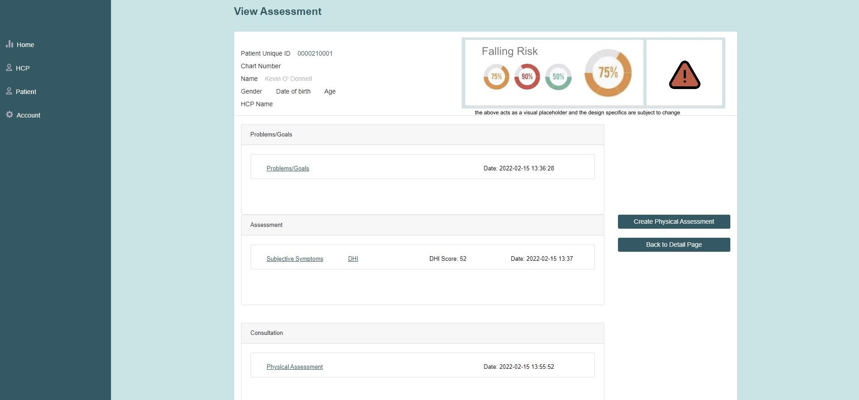

##### Expected User Experience:

Because vertigenius already has a web application, we don't need to make the UI from scratch, just modify it slightly. So we added a UI display about fall risk on the basis of its original.

Once on this page, a reminder of fall risk will appear visually in the form of a percentage scale and an exclamation point reminder. But the colour of the visualisation will change with the risk of falling, and when the risk is higher, the colour will be redder. At the same time, a yellow exclamation mark will appear if the patient's total risk of falling is greater than 50% or less. When a patient's fall risk exceeds 75%, a red exclamation mark will appear to make it easier for users to notice the risk.

The above is just a placeholder design and location, and is subject to change depending on the needs of the client and the circumstances of the data collected.

#### 3.4.2.Use cases (including text narratives)

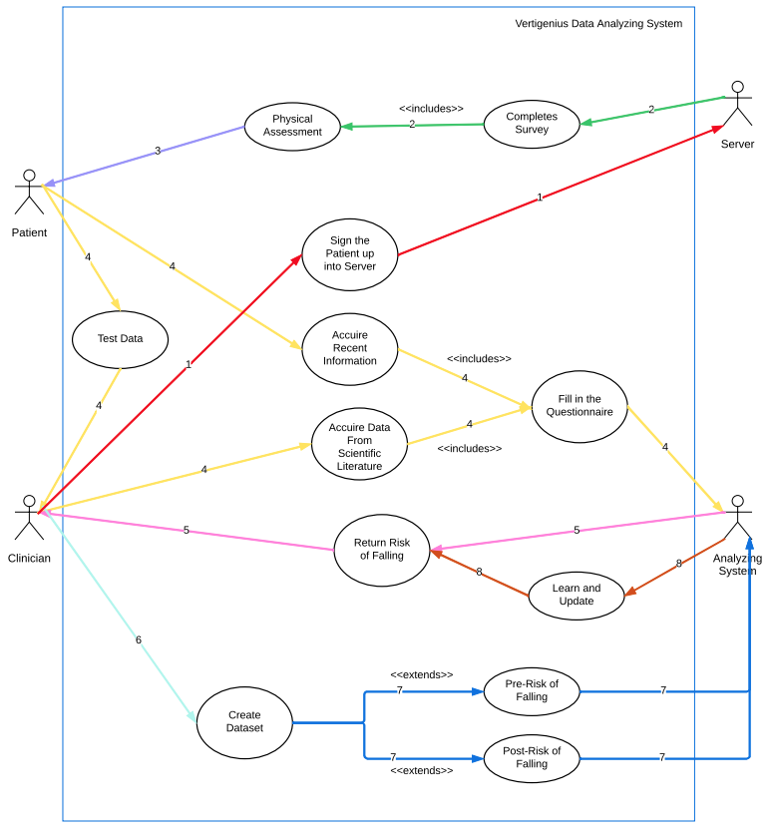

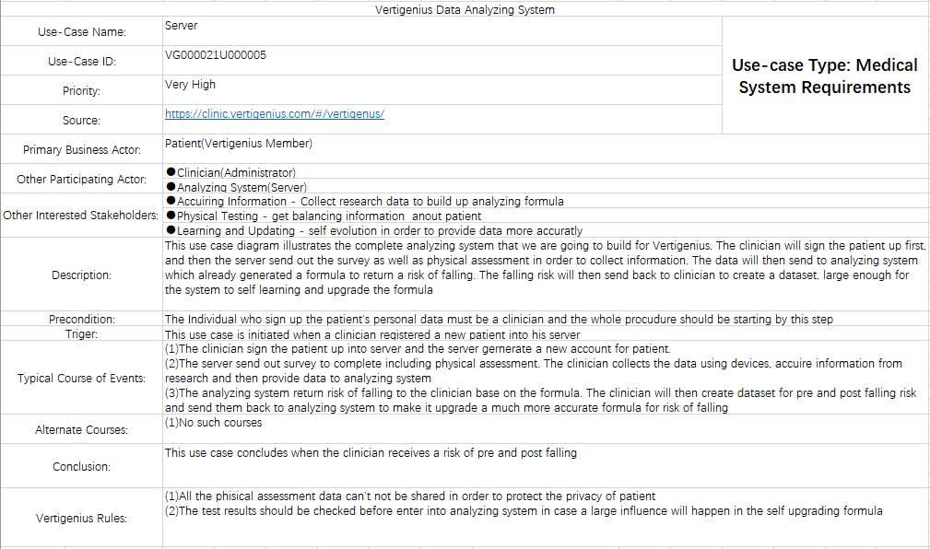

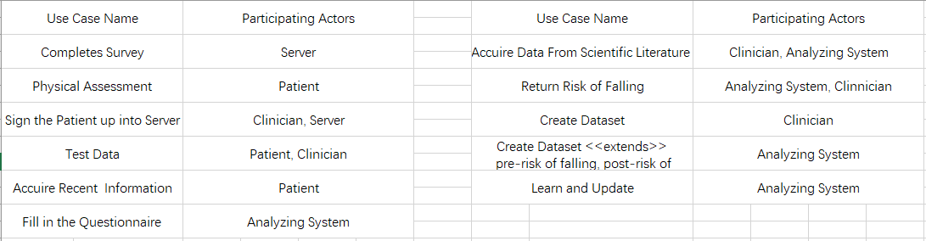

#### 3.4.3.Object model

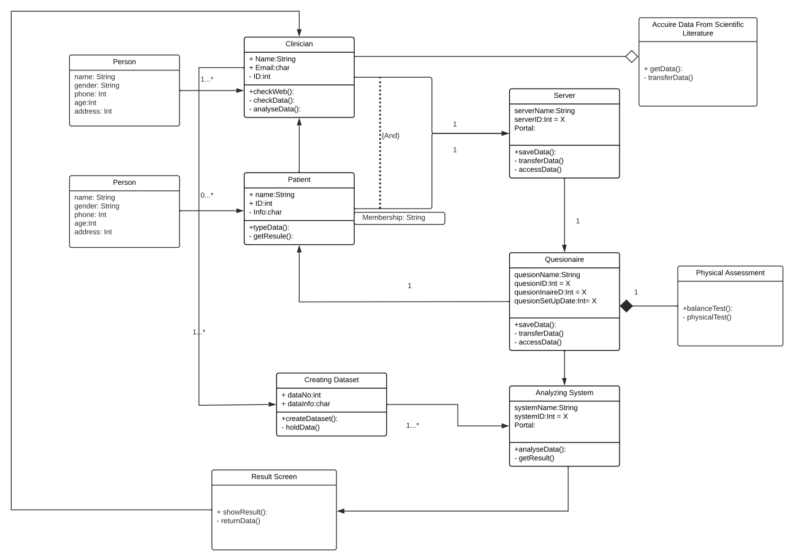

#### 

#### 3.4.4.Dynamic model

#### 

#### 

#### 